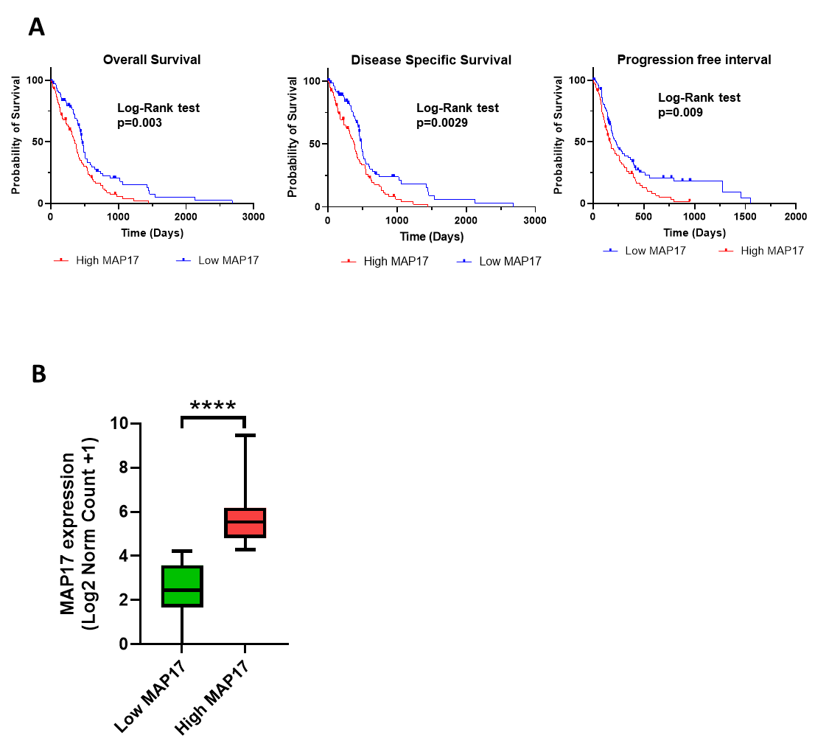
Supplementary Fig. 1. Survival analysis and expression levels of MAP17 in the GBM-TCGA cohort. A-Kaplan–Meier-Curve of overall survival, disease-specific survival, and progression-free survival analysis of MAP17 high (red) and low (blue) expression in the GBM cohort. Statistical analysis was conducted using the log-rank test. B-The log2-transformed, normalized gene expression of MAP17, showing the low versus high MAP17 group, based on the median expression level. Statistical analysis was performed using an unpaired t-test. ****p < 0.0001.

Supplementary Table 1. Gene abbreviation of metabolic-related pathways enriched in MAP17.
Gene ID | Full Name
Folate metabolism
SAA2 | Serum Amyloid A2
SAA1 | Serum Amyloid A1
CSF1 | Colony Stimulating Factor 1
SERPINA3 | Serpin Family A Member 3 (Alpha-1-Antichymotrypsin)
SERPINE1 | Serpin Family E Member 1 (Plasminogen Activator Inhibitor-1)
FOLR2 | Folate Receptor 2
FOLR1 | Folate Receptor 1
MTHFS | Methylenetetrahydrofolate Synthase
HBB | Hemoglobin Subunit Beta
SOD2 | Superoxide Dismutase 2
SOD3 | Superoxide Dismutase 3
IL6 | Interleukin 6
HBA1 | Hemoglobin Subunit Alpha 1
CCL2 | C-C Motif Chemokine Ligand 2
ICAM1 | Intercellular Adhesion Molecule 1
IL1B | Interleukin 1 Beta
Zinc homeostasis
SLC39A12 | Solute Carrier Family 39 Member 12
MT1F | Metallothionein 1F
MT1E | Metallothionein 1E
MT3 | Metallothionein 3
MT1L | Metallothionein 1L
MT1X | Metallothionein 1X
MT1G | Metallothionein 1G
MT1H | Metallothionein 1H
SLC39A8 | Solute Carrier Family 39 Member 8
MT1M | Metallothionein 1M
SLC39A4 | Solute Carrier Family 39 Member 4
MT1A | Metallothionein 1A
MT2A | Metallothionein 2A
Fatty acid metabolism
ALOX15B | Arachidonate 15-Lipoxygenase B
THEM4 | Thiol Esterase and Hydrolase 4
ACADS | Acyl-CoA Dehydrogenase, Short-Chain
AMACR | Alpha-Methylacyl-CoA Racemase
ALOX5 | Arachidonate 5-Lipoxygenase
GGT1 | Gamma-Glutamyltransferase 1
CBR1 | Carbonyl Reductase 1
ACADVL | Acyl-CoA Dehydrogenase, Very Long-Chain
MMAA | Methylmalonic Aciduria and Homocystinuria Type A
ACOX2 | Acyl-CoA Oxidase 2
AKR1C3 | Aldo-Keto Reductase Family 1 Member C3
PTGDS | Prostaglandin D2 Synthase
DPEP2 | Dipeptidase 2
ACOT13 | Acyl-CoA Thioesterase 13
CROT | Carnitine O-Octanoyltransferase
ACADL | Acyl-CoA Dehydrogenase, Long-Chain
MID1IP1 | MID1 Interacting Protein 1
CYP4F11 | Cytochrome P450 Family 4 Subfamily F Member 11
GGT5 | Gamma-Glutamyltransferase 5
GPX4 | Glutathione Peroxidase 4
ALOX5AP | Arachidonate 5-Lipoxygenase Activating Protein
PTGES | Prostaglandin E Synthase
PON3 | Paraoxonase 3
CYP4F3 | Cytochrome P450 Family 4 Subfamily F Member 3
PON2 | Paraoxonase 2
ELOVL7 | ELOVL Fatty Acid Elongase 7
GPX1 | Glutathione Peroxidase 1
ACSF2 | Acyl-CoA Synthetase Family Member 2
ACSL4 | Acyl-CoA Synthetase Long-Chain Family Member 4
ACAA2 | Acetyl-CoA Acetyltransferase 2
LTC4S | Leukotriene C4 Synthase
CYP2J2 | Cytochrome P450 Family 2 Subfamily J Member 2
HPGDS | Hematopoietic Prostaglandin D Synthase
ACSL5 | Acyl-CoA Synthetase Long-Chain Family Member 5
ACSL6 | Acyl-CoA Synthetase Long-Chain Family Member 6
MAPKAPK2 | Mitogen-Activated Protein Kinase-Activated Protein Kinase 2
CYP1B1 | Cytochrome P450 Family 1 Subfamily B Member 1
TBXAS1 | Thromboxane A Synthase 1
SLC22A5 | Solute Carrier Family 22 Member 5
ACOT11 | Acyl-CoA Thioesterase 11
PTGS2 | Prostaglandin-Endoperoxide Synthase 2 (Cyclooxygenase 2)
ACBD4 | Acyl-CoA Binding Domain Containing 4
PPT1 | Palmitoyl Protein Thioesterase 1
PTGR1 | Prostaglandin Reductase 1
ABCC1 | ATP Binding Cassette Subfamily C Member 1
NUDT7 | Nudix Hydrolase 7
ACADM | Acyl-CoA Dehydrogenase, Medium-Chain
ACOT4 | Acyl-CoA Thioesterase 4
ACSL1 | Acyl-CoA Synthetase Long-Chain Family Member 1
PTGR2 | Prostaglandin Reductase 2
HSD17B8 | Hydroxysteroid 17-Beta Dehydrogenase 8
SLC25A20 | Solute Carrier Family 25 Member 20
PHYH | Phytanoyl-CoA Hydroxylase
PTGS1 | Prostaglandin-Endoperoxide Synthase 1 (Cyclooxygenase 1)
PECR | Peroxisomal Enoyl-CoA Reductase
CYP2U1 | Cytochrome P450 Family 2 Subfamily U Member 1
ELOVL1 | ELOVL Fatty Acid Elongase 1
HSD17B12 | Hydroxysteroid 17-Beta Dehydrogenase 12
HSD17B3 | Hydroxysteroid 17-Beta Dehydrogenase 3
EPHX2 | Epoxide Hydrolase 2
ECHS1 | Enoyl-CoA Hydratase 1
ACOT9 | Acyl-CoA Thioesterase 9
ABCD1 | ATP Binding Cassette Subfamily D Member 1
PRKAG2 | Protein Kinase AMP-Activated Subunit Gamma 2
ACACB | Acetyl-CoA Carboxylase Beta
ALDH3A2 | Aldehyde Dehydrogenase 3 Family Member A2
Metabolism of vitamins and cofactors
BCO2 | Beta-Carotene Oxygenase 2
RETSAT | Retinol Dehydrogenase 12
PPCS | 4-Phosphopantetheinyl Transferase
APOE | Apolipoprotein E
VNN1 | Vanin 1
RBP4 | Retinol Binding Protein 4
NAMPT | Nicotinamide Phosphoribosyltransferase
APOC2 | Apolipoprotein C2
AKR1C3 | Aldo-Keto Reductase Family 1 Member C3
ACP5 | Acid Phosphatase 5
GPC4 | Glypican 4
LMBRD1 | LMBR1 Domain Containing 1
AKR1C1 | Aldo-Keto Reductase Family 1 Member C1
SPR | Serine Peptidase Inhibitor
RBP1 | Retinol Binding Protein 1
MOCOS | Molybdenum Cofactor Sulfurase
NNMT | Nicotinamide N-Methyltransferase
PLB1 | Phospholipase B1
GCH1 | GTP Cyclohydrolase 1
LRP2 | Low Density Lipoprotein Receptor-Related Protein 2
GCHFR | GTP Cyclohydrolase 1 Feedback Regulator
GPC5 | Glypican 5
TPK1 | Thiamine Phosphate Kinase 1
PARP8 | Poly(ADP-Ribose) Polymerase 8
SLC19A3 | Solute Carrier Family 19 Member 3
GSTO1 | Glutathione S-Transferase Omega 1
QPRT | Quinolate Phosphoribosyltransferase
PARP9 | Poly(ADP-Ribose) Polymerase 9
SLC25A19 | Solute Carrier Family 25 Member 19
ALDH1L1 | Aldehyde Dehydrogenase 1 Family Member L1
SDC2 | Syndecan 2
RNLS | Ribonuclease Like 5
VNN2 | Vanin 2
GSTO2 | Glutathione S-Transferase Omega 2
LRAT | Lecithin Retinol Acyltransferase
NMNAT3 | Nicotinamide Mononucleotide Adenylyltransferase 3
PTGS2 | Prostaglandin-Endoperoxide Synthase 2 (Cyclooxygenase 2)
PARP14 | Poly(ADP-Ribose) Polymerase 14
PARP10 | Poly(ADP-Ribose) Polymerase 10
CD38 | CD38 Molecule
FOLR2 | Folate Receptor 2
MTHFS | Methylenetetrahydrofolate Synthase
PNPO | Pyridoxamine 5'-Phosphate Oxidase
BST1 | Bone Marrow Stromal Antigen 1
SDC4 | Syndecan 4
SLC2A3 | Solute Carrier Family 2 Member 3
PRSS3 | Serine Protease 3
AOX1 | Aldehyde Oxidase 1
Glycolysis gluconeogenesis
HK3 | Hexokinase 3
PCK2 | Phosphoenolpyruvate Carboxykinase 2
PGAM2 | Phosphoglycerate Mutase 2
ALDH9A1 | Aldehyde Dehydrogenase 9 Family Member A1
ALDH7A1 | Aldehyde Dehydrogenase 7 Family Member A1
ALDH2 | Aldehyde Dehydrogenase 2
GCK | Glucokinase
ALDH3B1 | Aldehyde Dehydrogenase 3 Family Member B1
GALM | Galactose-1-Phosphate Mutarotase
ALDH3A1 | Aldehyde Dehydrogenase 3 Family Member A1
ALDOA | Aldolase A (Fructose-Bisphosphate Aldolase)
HK2 | Hexokinase 2
ENO2 | Alpha-Enolase
LDHA | Lactate Dehydrogenase A
FBP1 | Fructose-1,6-Bisphosphatase
PGK1 | Phosphoglycerate Kinase 1

